PGE186 Tools

version 1.1

# need

Several tools for PGE186 line data sheets in Excel have been developed to reduce time to do repetitive tasks, including:

* Changing the background color of rows based on the Change Type of each row
* Changing tower numbers, like “34/7” to the standard with leading zeroes, like “034/007” and turning it red.
* Adding Change ID numbers (A1,TLS3, C5, etc.) based on the Change Type and Item

Combining these tools in an Excel Add-In can give access to all these tools from buttons in a custom “PGE186” toolbar group.

# SUMMARY

On your file system:

1. Copy P:\PGE186\Code Tricks\Excel - PGE186 Tools.xlam to your local Add-Ins folder: C:\Users*<username>*\AppData\Roaming\Microsoft\AddIns, where *<username>* is the username you log in with.
2. If a previous version of this file already exists in this folder, allow it to be overwritten.

If you have installed this Add-In once, it will load in place of the previous version without having to do the steps below. If this is your first time installing the Add-In, do the following in any Excel file:

1. Click File > Options
2. Click Add-ins in the left navbar
3. In the bottom of the window, next to Manage:, make sure it reads “Excel Add-ins” on the pulldown and press Go…

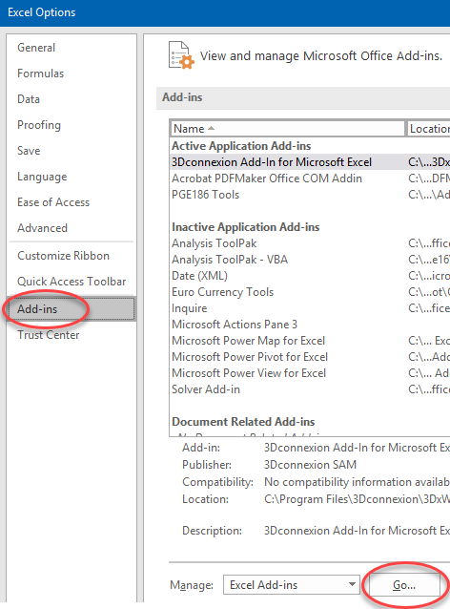

1. Click Browse… and navigate to C:\Users*<username>*\AppData\Roaming\Microsoft\AddIns
2. Select Excel - PGE186 Tools.xlam and click OK.
3. Notice there is a new entry in the Add-ins list: “PGE186 Tools”, checked on. Click OK.
4. Back in your Excel file, notice there is a new tab on the ribbon, “PGE186”: 

This tab holds the PGE186 tool buttons.

# Details of Solution

TBA